Adding a new Item
KCD2 stores all the database entries in .XML files found in Data/libs/Tables/... or in Tables.pak/Tables/... - the summary and more information about them can be found at Database tables.
There are a lot of database tables that control all sorts of things in the game - since we can't cover every aspect of the game, let's focus on a (probably) frequent and simple use case: adding a new item to the game.
Creating a new item
All the items are in the tables at Data/libs/Tables/Item/item.xml and its subfiles, e.g. item__unique.xml, item__alchemy.xml. These subfiles are there just for easier browsing and editing. The whole item system is a bit too complicated for a tutorial of this scope, so we can use entries in these files as a template to create our own items. You should always mod the base file, not the sub-files.
Our mod will be called sword_example, so we will use this as the mod's modid.
- Create a mod's patch table for items, it should be located in Data/libs/Tables/Item/ and called item__<modid>.xml, in our case it's going to be Data/libs/Tables/item/item__sword_example.xml.
  - The game will load this "patch" file and modify an existing entry or add a new one
- We want to add a new sword that will be extremely overpowered and called after us. First of all we need to find a correct row to use as a template for our sword.
  - All melee weapons are grouped up together and use <MeleeWeapon ... tag, then they further divide into different weapon classes.
Let's study a randomly chosen <MeleeWeapon.. entry and see what item it creates (the name parameter obviously spoils it - it's a Warhammer):
<MeleeWeapon Attack="20" AttackModStab="0" AttackModSlash="0" AttackModSmash="1" Class="5" SubClass="6" Defense="8" MaxStatus="1" StrReq="3" AgiReq="5" IsBreakable="false" Visibility="1" Conspicuousness="1" Charisma="5" SocialClassId="0" WealthLevel="17" MaxQuality="1" IconId="mace_broken" UIInfo="ui_in_warhammer03_trollslayer_broken" UIName="ui_nm_warhammer03_trollslayer_broken" Model="manmade/weapons/war_hammers/warhammer03_damaged.cgf" Weight="1" Price="1" FadeCoef="133.333328" VisibilityCoef="0.83666" Id="93a87db1-c332-409a-9044-6e54b516c0ee" Name="warhammer03_trollslayer_broken" />
We can see the parameters Class="5" SubClass="6" , let's cross-reference these to tables weapon_class.xml and weapon_sub_class.xml to check what they mean:
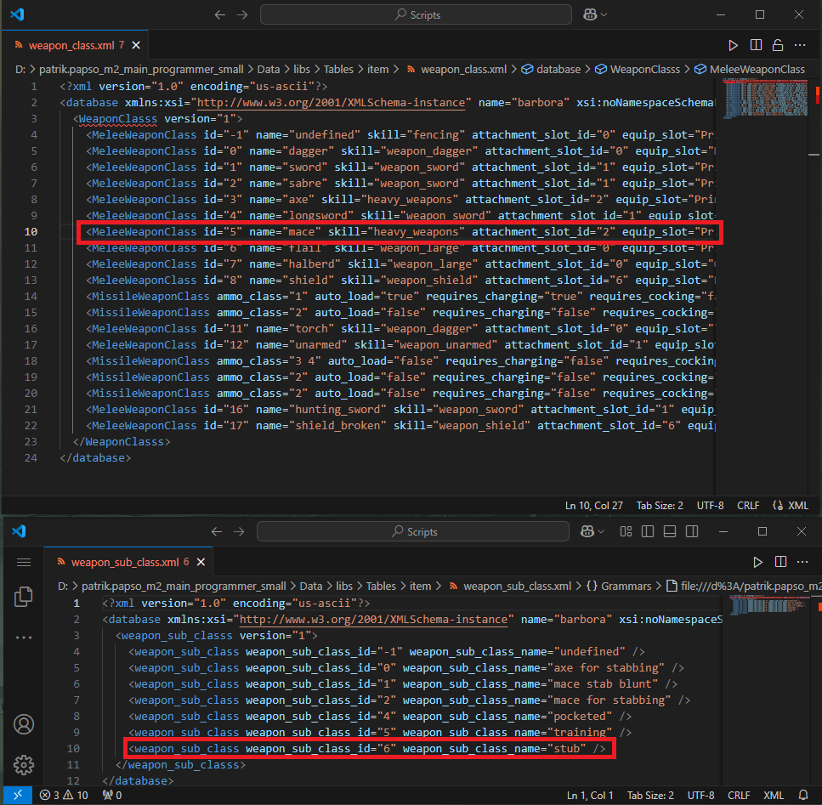
Thanks to that, we now know it's a mace (that uses heavy_weapons skill), equips into PrimaryMainHand and its subclass is stub.
- After browsing weapon_class.xml we now know we want to find a <MeleeWeapon... with class="4", because that's a longsword, e.g.:
<MeleeWeapon Attack="166" AttackModStab="1.05" AttackModSlash="1" AttackModSmash="0.2" Class="4" Defense="259" MaxStatus="141" StrReq="17" AgiReq="20" IsBreakable="true" BrokenItemClassId="584cf614-367b-413b-be8d-20bc5d275b74" Visibility="1" Conspicuousness="1" Charisma="5" SocialClassId="0" WealthLevel="0" MaxQuality="4" Clothing="Scabbard_LongSword04_m02" IconId="sermiry_longSwordGuild" UIInfo="ui_in_sermiry_guildSword" UIName="ui_nm_sermiry_guildSword" IsQuestItem="true" Model="manmade/weapons/swords_long/sermiri_long_sword_guild.cgf" Weight="2.6" Price="30985" FadeCoef="1" VisibilityCoef="16.75112" Id="036661e4-4556-4295-82f3-264e48cb2d49" Name="sermiry_longSwordGuild" />
This is a quest sword from the quest "sermiri", so we will have to modify a bit, we want to turn it into a normal item, increase damage, change the name, make it so it can't break etc. DON'T FORGET TO MODIFY THE GUID, since we don't want 2 items with the same GUID (the game would explode and we don't want that). Let's use an online tool to create a unique one.
4. With all these changes, we end up with a file that looks like this:
<?xml version="1.0" encoding="us-ascii"?>
<database xmlns:xsi="http://www.w3.org/2001/XMLSchema-instance" name="barbora" xsi:noNamespaceSchemaLocation="item.xsd">
<ItemClasses version="8">
<MeleeWeapon Attack="1337" AttackModStab="10" AttackModSlash="10" AttackModSmash="10" Class="4" Defense="1000" MaxStatus="141" StrReq="1" AgiReq="1" IsBreakable="false" Visibility="1" Conspicuousness="1" Charisma="20" SocialClassId="0" WealthLevel="0" MaxQuality="4" Clothing="Scabbard_LongSword04_m02" IconId="sermiry_longSwordGuild" UIInfo="bluex_overpowered_sword" UIName="bluex_overpowered_sword" IsQuestItem="false" Model="manmade/weapons/swords_long/sermiri_long_sword_guild.cgf" Weight="2.6" Price="30985" FadeCoef="1" VisibilityCoef="16.75112" Id="f0307884-141d-485f-8667-b421391712de" Name="bluex_overpowered_sword" />
</ItemClasses>
</database>
Getting the item into the game
We managed to create the item itself, but right now the only way to get it is via a debugging tool (that you can't use in the real game)
- The game uses inventory presets to populate NPCs/Stashes with items, these tables can be again found at Data/libs/Tables/item/ and are called InventoryPreset.xml and subfiles are InventoryPreset__... . Same as with Item.xml - the subfiles are there for easier browsing and editing.
- We will directly add this item to Henry's inventory, for that we have to find InventoryPreset__player.xml and check how it's structured
InventoryPreset__player.xml:
<?xml version="1.0" encoding="us-ascii"?>
<database xmlns:xsi="http://www.w3.org/2001/XMLSchema-instance" name="barbora" xsi:noNamespaceSchemaLocation="InventoryPreset.xsd">
<InventoryPresets version="2">
<InventoryPreset Name="inventory_player_bohuta">
<InventoryPresetRef Name="inventory_tneb_bohuta" />
<PresetItem Name="keyring" Amount="1" />
</InventoryPreset>
<InventoryPreset Name="inventory_player_henry">
<PresetItem Name="keyring" Amount="1" />
</InventoryPreset>
</InventoryPresets>
</database>
Therefore, we want to patch inventory_player_henry and our modded InventoryPreset__sword_example.xml should look like this:
(Don't forget, that we want to patch directly InventoryPreset.xml and not the sub-table __player)
(This will be changed in patch 1.3 - inventory presets will be easier to merge)
<?xml version="1.0" encoding="us-ascii"?>
<database xmlns:xsi="http://www.w3.org/2001/XMLSchema-instance" name="barbora" xsi:noNamespaceSchemaLocation="InventoryPreset.xsd">
<InventoryPresets version="2">
<InventoryPreset Name="inventory_player_henry">
<PresetItem Name="keyring" />
<PresetItem Name="bluex_overpowered_sword" />
</InventoryPreset>
</InventoryPresets>
</database>
Testing the mod
Now that we created a new item and added it to the player's inventory, let's check ingame if everything works! kcd.log looks good, both table patches are loading correctly:
<16:25:41> Patched database Item with file `item__sword_example.xml`.
<16:25:42> Patched database InventoryPreset with file `InventoryPreset__sword_example.xml`.
When we open Henry's inventory, we can see our overpowered sword sitting there:
